CALEDONIA MINOR BASEBALL ASSOCIATION
(CMBA)

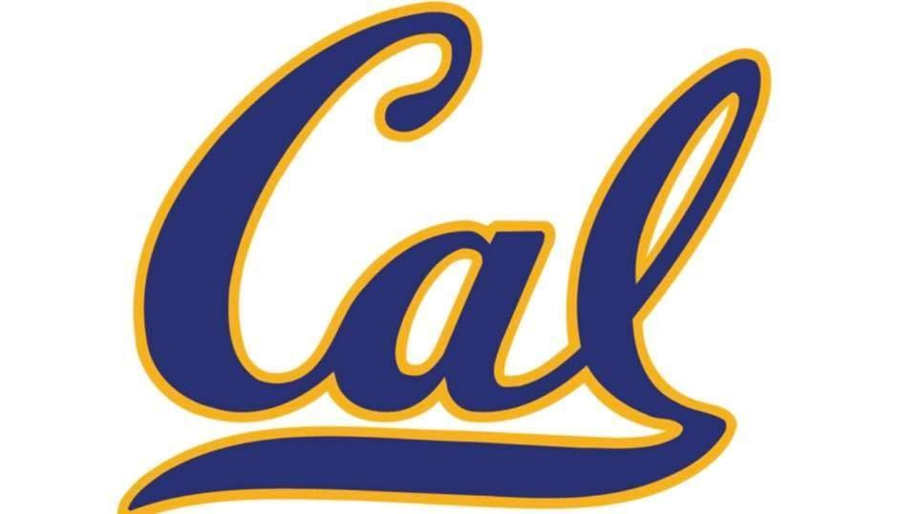

Rep Policy and Code of Conduct

TABLE OF CONTENTS

SECTION 1.0 REP TEAM POLICY PAGE 3

SECTION 2.0 REP TEAM TRY OUTS PAGE 4

SECTION 3.0 RELEASES PAGE 5

SECTION 4.0 EXTERNAL RELEASES PAGE 5

SECTION 5.0 REP TEAM UNIFORMS PAGE 5

SECTION 6.0 REP TEAM FINANCIAL PAGE 5

SECTION 7.0 CODE OF CONDUCT PAGE 6

SECTION 1.0- REP TEAM POLICY

- Caledonia Minor Baseball Association (CMBA) has a mission as an organization to offer the youth of Caledonia and surrounding area, a quality baseball program for their recreation and athletic development. Further, we maintain an objective to match the level of competition to what their individual skills warrant. Consistent with this objective, the CMBA offers Rep baseball programs to facilitate a higher level of competition for players with advanced skill sets and a desire for increased competitive opportunities beyond our normal house league play.

- The CMBA is an Association governed by the Southern Counties Baseball Association (SCBA), an Affiliate of Baseball Ontario (OBA).

- Rep teams may participate in SCBA league play and normally participate in additional OBA sanctioned tournaments throughout the season. The Rep seasons are focused on development to qualify for OBA provincial championship tournaments held at the end of the summer.

- CMBA is eligible for OBA Provincial play at B, C or D levels but may qualify from time-to-time for higher level play depending on the competitive level of individual teams. To qualify at a higher series (e.g., “A”, “AA”) the team in question would need to get approval from the CMBA Executive to do so.

- Wherever possible, the CMBA Executive will strive to form Major and Minor teams for each Division of play where the number of players allows for this.

- Prospects that are Minor age may try out for the Major team but are not required to in their age grouping.

- Aspiring Rep Coaches will be required to apply on-line prior to the posted deadline. When two or more applications are received within the same division, CMBA will conduct Coaching interviews. Based on these interviews CMBA will select the Rep Coach. (There will be no appeal process)

- Rep tryouts will be conducted in the fall prior to the upcoming season. Coaches will be required to have finalize their roster no later than October 15th.

SECTION 2.0- REP TEAM TRY OUTS

- To be eligible for a CMBA Rep team, a player must attend the scheduled tryouts for the appropriate team for that player’s age category and be in adherence with the policies and procedures outlined.

- Exceptions may be granted by the CMBA Executive. Exceptions must be reviewed and receive a majority vote by the CMBA Executive. In cases where a player is injured and unable to participate in the tryouts, every effort should be made to attend the tryouts and assist in any way possible. Medical documentation may be requested by the CMBA Executive.

- Prior to tryouts, “non-resident” SCBA players must provide a current “Permission to Practice form” supplied to them by the baseball association where they reside, or they will be excluded from CMBA tryouts until a valid “Permission to Practice” is presented.

- A player not meeting the above criteria and found to be included on a CMBA Rep team's roster without the consent of the CMBA Executive will be immediately removed from that roster. Release requests in these cases will not be considered.

- No coach will alter or make exception to these policies alone. These exceptions must be brought to the CMBA Executive for consideration and ruling.

- No decision on whether a player has made the team or not will occur before the end of the third scheduled tryout. This allows all players a fair opportunity to fully demonstrate their abilities.

- All Rep tryouts will be coordinated and scheduled jointly by the CMBA Executive and selected Rep team coaches.

- CMBA Executive members may visit tryouts to ensure compliance by all.

- Any exceptions to the above rules must be reviewed and approved by the CMBA Executive Committee

SECTION 3.0- RELEASES

- CMBA players must attend the appropriate CMBA Rep team tryouts. If they do not attend, release requests will not be considered.

- A player that is selected for a CMBA Rep team after trying out, who refuses to play with that team, will then be assigned to a CMBA House League team for that year and no release requests will be considered.

- If SCBA is not offering at Tier 1 team within your age group a release can be present to CMBA to discuss.

SECTION 4.0- External Releases

If a CMBA player wishes to play for a Local Association in an OBA Affiliate other than SCBA, a written release is required from CMBA and SCBA.
The player must first request a release from the CMBA which holds the players playing rights. If it is granted, then a request for release must be made to SCBA. If a release request is denied by CMBA, the decision may be appealed to the SCBA. If it is denied by the SCBA, then it may be appealed to the OBA. Fees will be charged for each appeal.

SECTION 5.0- REP UNIFORMS

All CMBA rep team uniforms and apparel that are worn in the park at any OBA, or SCBA sanctioned game must be the uniforms issued by the CMBA. Any additional apparel must be approved and ordered through the CMBA Executive and must be of CMBA colors: Navy Blue, Yellow.

SECTION 6.0- FINANCIALS

- All players on a CMBA rep team will be charged the current teams Rep Fee in addition to the current year’s registration fee, as determined by the CMBA Executive.
- For a Rep team to qualify for the CMBA to pay their OBA Provincial Tournament entry fee or award money from the CMBA, the following conditions must be met.
  - All players on the team have fully paid for registration and rep fees.
  - A team must not have any outstanding fines against the team from the OBA or SCBA.
  - A team must fulfill all fundraising obligations throughout the current baseball year, from September to September. This will include helping with tournaments that the CMBA is hosting, and any other fundraising project given to the team by the CMBA Executive.

SECTION 7.0 COACHES CODE OF CONDUCT

As a coach or other team official within the CMBA, I understand that I am representing my team, our association and my community. I will therefore conduct myself at all times, while at Henning Park or any other baseball facility in a respectful and sportsmanship manner. While present at a baseball game, practice or any other baseball related activity or function, I will follow all guidelines and established principles of CMBA, SCBA, OBA, Haldimand County’s “Public Conduct on County Property” Policy and any other league or association rules as applicable.
I will respect Henning Park property and any other baseball field or facility at all times. I will treat executive members, my players, our opponents and any other team or league official with respect and dignity. I will never verbally or physically abuse an official.

I will also adhere to the following:
a) I will read, understand and follow the guidelines as outlined in the CMBA, SCBA and OBA Constitutions and conduct policies
b) I will read, understand and follow the guidelines as outlined in the “Public Conduct on County Property” Policy;
c) I will attend all Coach’s meetings or requested board meetings as required;
d) I will ensure equal opportunity for all players on the team to succeed and grow;
e) I will never be alone with my players;
f) I will return all equipment and supplies provided to me by CMBA at the end of the season;
g) I will be responsible for the well being of all players while they are in my care;
h) I will request the assistance of the applicable Executive member for any issues I cannot handle;
i) I will never be under the influence of alcohol or any illegal substance while players are in my care;
j) I will report any injuries and all ejections or suspensions immediately to the Executive Committee;
k) I will communicate with my player’s / parents on a regular basis and I will ensure a full accounting of team funds is provided with a zero balance at season end.
l)All communication with the Executive Committee of CMBA will be done through email for all questions, concerns or issues. All other forms of communication will not be considered formal or be responded to.
m) any disagreements with parents/players, coaches, umpires, executive staff must follow the 24 hour cool down rule for any communication

I understand that failure to comply with this Coaching Staff Code of Conduct may result in disciplinary action. Such action may result in my losing my coaching privileges and/ or the opportunity to participate in CMBA activities and events, both present and future.

